Name …………………………………………………………Signature ……………………
P530/1
BIOLOGY
Paper 1
July. 2016 Uganda Advanced Certificate of Education
2½ hours
External Facilitation Exams 2016
BIOLOGY
(THEORY)
Paper 1
2 hours 30 minutes
INSTRUCTIONS TO CANDIDATES:
This paper consists of sections A and B.
Answer all questions in both sections.
SECTION A:
Answers to this section must be written in the boxes provided.
SECTION B.
Answers to this section should be written in the spaces provided and not anywhere else. No additional sheets of paper should be inserted in this booklet.
For Examiner’s use only
Section | Marks
A: 1-40
B: 41
42
43
44
45
46
Total

SECTION A (40 MARKS)
- In each of the following cases an RH- mother is not likely to develop antibodies against an RH + foetus except when she is of blood group O and the foetus is blood group

- A
- O
- AB
- B

- Which of the following cell types divides to produce cells that make antibodies?

- Helper T cells
- B cells
- Cytotoxic T cells
- Neutrophils

- The fact that all native mammals of Australia are marsupials and they are not represented elsewhere in the world is evidence for evolution that is basically

- developmental
- biogeographic
- genetic
- fossil in nature

- The part of the brain that controls language, memory sensations and decision making is the

- cerebrum
- thalamus
- hypothalamus
- cerebellum

- Simple diffusion of hydrophobic molecules is aided across the plasma membrane by

- glycoprotein
- globular protein
- transmembrane protein
- lipids

- Figure 1 shows a structure found in a chloroplast
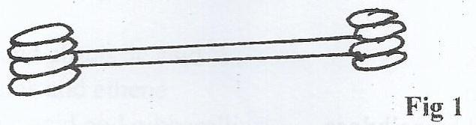

Which of the following is the correct function of this structure?
- Storage of starch
- Oxidation of chloroplast
- Synthesis of electron carriers
- Harnessing light energy

- Which of the following is a direct ecological effect of global warming?

- Extinction of species
- Death of organisms
- Reduction in diversity
- Melting of ice caps

- The synthesis and assembly of cell wall components is a function of the

- Golgi body
- microtubules
- ribosomes
- cell membrane

- The diameter of glomerular capillaries is much less than that of the arterioles in order to

- eliminate glucose from the filtrate
- raise the filtration pressure
- eliminate proteins from urine
- slow down the process of filtration

- The walls of sclerenchyma cells stain yellow in aniline chloride because they

- are very thick
- contain lignin
- are thickened by cellulose
- contain suberin

- Which of the following is true of meiosis I but not of mitosis ?

- Two daughter cells are produced
- Disappearance of the nucleolus
- Spindle fibers are formed
- Bivalents are formed

- Production of red blood cells in the mammalian fetus is carried out by the

- bone marrow
- liver
- spleen
- lymph nodes

- Which of the following factors determines the ecological range of a mobile animal?

- Breeding space
- Availability of food
- High temperatures
- Size of the community

- During carbon dioxide transport the movement of chloride ions from the plasma into red blood cells is aimed to

- restore its water potential
- maintain the blood PH
- restore electro neutrality of the cell
- maintain a larger diffusion gradient for ions

- Which one of the following pairs of hormones would be most active during periods of physiological stress in plants?

- Ethane and abscissic acid
- Cytokinins and ethene
- Abscissic acid andgibberellins
- Ethane and auxins

- Contraction of the internal intercostal muscles results into

- increased pressure in the thorax
- the ribs moving inwards and downwards
- lowering the volume of the chest cavity
- flattening of the diaphragm

- Below are some features of members in phylum arthropoda
- Distinct head
- Water proof exoskeleton
- Herbivorous nature
- Bilateral symmetry
Which of the above features are common to both Chilopoda and Diplopoda
- 1,2 and 3 only
- 1,2,3 and 4
- 1 and 3 only
- 1,2 and 4 only

- Which of the following epithelial tissues lines the oviduct?

- Stratified
- Cuboidal
- Squamous
- Ciliated

- Which one of the following may result into pest resurgence?

- Incorporation of the pesticide into the food chain
- Use of a broad spectrum pesticide
- Using more than two treatments on the same pest
- Use of a persistent pesticide

- Which one of the following statements is consistent with the mass flow theory?

- Only organic molecules can be transported in the vascular tissues
- Molecules tend to move independently of each other
- Only inorganic molecules can be transported in the conducting tissues
- All materials are transported together at similar velocities

- Figure 2 shows the changes which occur during the menstrual cycle
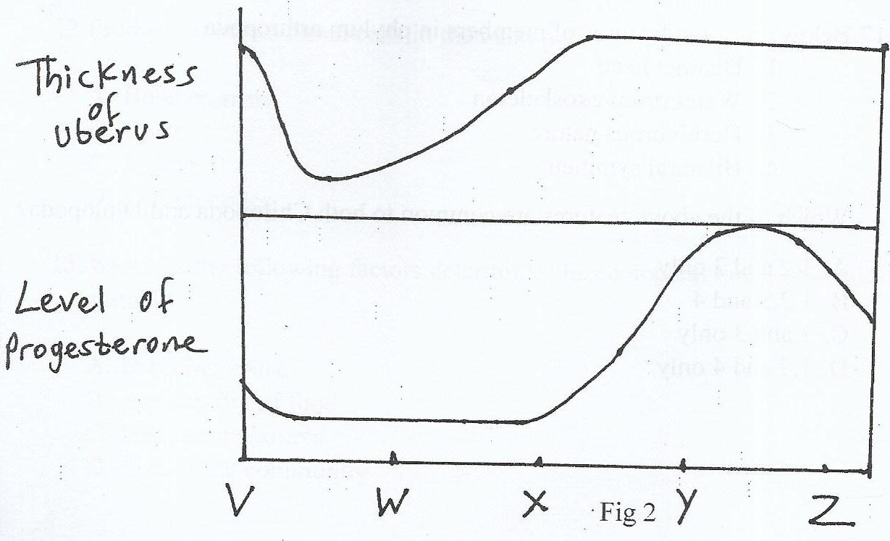

Between which of the above point marks is implantation most likely to be successful if fertilization takes place
- V and W
- X and Z
- W and Y
- X and Y

- Removal of the thyroid gland from a young mammal is likely to result into its death because of

- degeneration of brain cells
- deficiency of lymphocytes
- inhibition of protein synthesis
- deterioration of other glands

- The following are effects of territorial behavior except

- reduced reproductive fitness
- increased variation
- reduced competition
- increased inbreeding

- A column of water in the xylem vessels of a tree ascends without breaking mainly due to

- adhesion
- capillarity
- root pressure
- cohesion

- Which one of the following groups of bacteria uses nitrate ions as their electron acceptor in the respiratory pathway?

- Nitrifying bacteria
- Photosynthetic bacteria
- Denitrifying bacteria
- Pathogenic bacteria

- The function of the loop of Henle is to

- regulate the volume of blood plasma
- create a gradient of sale concentration in the medulla
- enable mammal to excrete dilute
- maintain water reabsorption from the tubules

- In the course of pregnancy the placenta takes over the role of producing oestrogen and progesterone because

- menstruation is terminated
- corpus luteum has persisted
- menstruation has commenced
- corpus luteum has degenerated

- Which of the following factors may not cause oxyhaemoglobin to release oxygen to active muscle tissues?

- High temperature in the tissues
- Ligh levels of carbon dioxide in the tissues
- Low levels of carbon dioxide in the tissues
- A steep concentration gradient between the blood and tissues

- One advantage of mammalian lungs being seated within the chest cavity is to

- conserve energy for the other activates
- ensure a continuous supply of respiratory gases
- minimize water losses from the alveolar surface
- ensure rapid removal of waste gases

- Which one of the following pairs of structures are not homologous?

- arms of humans and wings of birds
- legs of insects and those of mammals
- Pods of beans and pericarps of maize grains
- Pectoral fins of fish and arms of humans

- Excessive variation in the calcium ion content of blood may result into

- shrinking of the body
- mental retardation
- neuromuscular disturbances
- hardening of bones

- Which one of the following is not found in the body cells of obligate anaerobes?

- Sugars
- Glycolytic enzymes
- ATP
- Mitochondria

- Which one of the following is the primary function of the lymphatic tissue?

- Filtration of foreign particles out of blood
- Production and storage of white blood cells
- Transport of excess tissue fluid back into the blood
- Transport of cholesterol molecules into the blood

- Which one of the following is a form of vegetative propagation?

- Spore formation
- Conjugation
- Budding
- Parthenogenesis

- Which one of the following processes does not utilize oxygen?

- Detoxification
- Deamination
- Oxygen debt
- Aerobiosis

- The following functions are performed by plant roots except

- absorption of oxygen
- production of new calls
- provision of support
- storage of wastes

- In which of the following parts of the mammalian testis does meiosis occur?

- Primordial germ cell
- Seminiferous tubules
- Leydig cells
- Sertoli cells

- What is the significance of the three semicircular canals being in different plants?

- Allows rapid transmission of sound vibrations
- Allows detection of changes of movement in various directions
- Allows transmission of information to several parts of the nervous system
- Brings about summation of information from various directions

- Which type of population growth curve arise in a population that is characterized by explosions followed by declines?

- logarithmic
- logistic
- Boom and bust growth curve
- Cyclic population growth curve

- Earthworms have a large number of looped blood capillaries in their epidermis in order to
- Reduce the diffusion distance between the body surface and blood vessels
- Provide a larger surface area for diffusion
- Increase on the pumping action of the pseudo hearts
- Maintain a steep concentration gradient for gaseous exchange.

SECTION B (60 MARKS)
- Table 1 shows the relative number of stomata and relative transpiration rates for four different plant species
Plant species | A | B | C | D
Relative number of stomata mm⁻² of leaf  (upper :lower leaf surface) | 5:30 | 0:80 | 10:15 | O:50
Relative transportation rate  (upper :lower leaf surface) | 10:12 | 0:4 | 15:30 | 20:50

a) Comment on the relative distribution of stomata in the four species (02 marks)
......................................................................................................................................................
......................................................................................................................................................
......................................................................................................................................................
......................................................................................................................................................
......................................................................................................................................................
......................................................................................................................................................

b) Comment on the relationship between the distribution of the stomata and the transpiration rate in species B and D
(i) Species B ( 02 marks)
......................................................................................................................................................
......................................................................................................................................................
......................................................................................................................................................
......................................................................................................................................................
......................................................................................................................................................
......................................................................................................................................................
(ii) Species D (02 marks)
......................................................................................................................................................
......................................................................................................................................................
......................................................................................................................................................
......................................................................................................................................................
c) Explain the rates of transpiration observed in
(i) Species D (02 marks)
......................................................................................................................................................
......................................................................................................................................................
......................................................................................................................................................
......................................................................................................................................................
......................................................................................................................................................

(ii) Species B (02 marks)
......................................................................................................................................................
......................................................................................................................................................
......................................................................................................................................................
......................................................................................................................................................
......................................................................................................................................................
42. a) Give one example of each of the following in humans (02 marks)

(i) Endoparasite......................................................................................................................

(ii) Ectoparasite.......................................................................................................................
b) Explain why parasites produce large numbers of offspring (02 marks)
......................................................................................................................................................
......................................................................................................................................................
......................................................................................................................................................
......................................................................................................................................................
......................................................................................................................................................
c) Distinguish between obligate and facultative parasites (02 marks)
......................................................................................................................................................
......................................................................................................................................................
......................................................................................................................................................
......................................................................................................................................................
......................................................................................................................................................
d) List two ways in which the nutrition of parasites and saprophytes are similar (03 marks)
......................................................................................................................................................
......................................................................................................................................................
......................................................................................................................................................
......................................................................................................................................................
......................................................................................................................................................

e) State one way how parasites have overcome the constraints of a restrictive parasitic mode of life on their successful reproduction (01 mark)
......................................................................................................................................................
......................................................................................................................................................
......................................................................................................................................................
......................................................................................................................................................
......................................................................................................................................................
43 a) With an example explain what is meant by releasers (02 marks)
......................................................................................................................................................
......................................................................................................................................................
......................................................................................................................................................
......................................................................................................................................................
......................................................................................................................................................
(b) State two forms of behavior that are prompted by releasers (02 marks)
......................................................................................................................................................
......................................................................................................................................................
......................................................................................................................................................
......................................................................................................................................................
......................................................................................................................................................
(c) Give three functions of releasers in animal behavior (03 marks)
......................................................................................................................................................
......................................................................................................................................................
......................................................................................................................................................
......................................................................................................................................................
......................................................................................................................................................
(d) Describe three ways how hormones may influence an animal’s behavior (03 marks)
......................................................................................................................................................
......................................................................................................................................................
......................................................................................................................................................
......................................................................................................................................................
......................................................................................................................................................
44. Table2 shows the relative concentration of urine of different mammals relative to the concentration in man
Mammal | Urine concentration  (relative to man) | Thickness of medulla  (relative to remainder of kidney)
Man | 1.00 | 3.0
Sheep | 0.70 | 2.2
Rat | 1.92 | 5.4
Organism X | 3.73 | 8.9

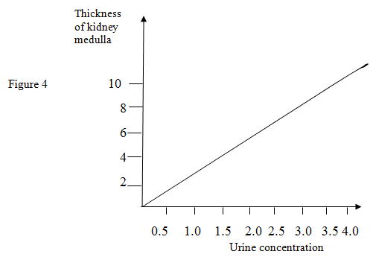
a) (i) on the curve provided plot the positions of the different mammals shown in the table (02marks)
(ii) State the relationship between the relative medulla thickness and urine concentration (02 marks)
......................................................................................................................................................
......................................................................................................................................................
......................................................................................................................................................
......................................................................................................................................................
......................................................................................................................................................
(iii) Explain the relationship between the relative medulla thickness and urine concentration (03 marks)
......................................................................................................................................................
......................................................................................................................................................
......................................................................................................................................................
......................................................................................................................................................
......................................................................................................................................................
......................................................................................................................................................
......................................................................................................................................................
......................................................................................................................................................
......................................................................................................................................................
b) Suggest with reasons the possible habitat of organism X (03 marks)
......................................................................................................................................................
......................................................................................................................................................
......................................................................................................................................................
......................................................................................................................................................
......................................................................................................................................................
45. Figure 5 represents a simple food web of five organisms A, B, C, D and E
A

B C

D E
a) Describe what would happen to the populations of A and B organisms with time if organism C was suddenly removed from the area (03 marks)
......................................................................................................................................................
......................................................................................................................................................
......................................................................................................................................................
......................................................................................................................................................
......................................................................................................................................................
......................................................................................................................................................
......................................................................................................................................................
......................................................................................................................................................
......................................................................................................................................................
Figure 6 shows the distribution of four species of organisms at different depths in a pond. The pond is 3 m deep

b) Giving a reason in each case state which species is likely to be the
(i) Main producer (03 marks)
......................................................................................................................................................
......................................................................................................................................................
......................................................................................................................................................
......................................................................................................................................................
(ii) Secondary consumer (02 marks)
......................................................................................................................................................
......................................................................................................................................................
......................................................................................................................................................
......................................................................................................................................................
c) Decomposer (02 marks)
......................................................................................................................................................
......................................................................................................................................................
......................................................................................................................................................
...................................................................................................................................................... ......................................................................................................................................................
......................................................................................................................................................

46. In Drosophilla ,grey body is dominant over black body and is non sex linked. Red eye is dominant over white eye and is sex linked
a) Reconstruct the genotype and phenotype of the parents for the following described progenies. (Let G represent the grey body allele, g the black body allele, R the red eye allele and r the white eye allele)
Males ¾ grey, white: ¼ black white
Females ¾ grey, red: ¼ black red
Show your reasoning (03 marks)
......................................................................................................................................................
......................................................................................................................................................
......................................................................................................................................................
......................................................................................................................................................
......................................................................................................................................................
......................................................................................................................................................
......................................................................................................................................................
......................................................................................................................................................
..................................................................................................................................................... ......................................................................................................................................................
......................................................................................................................................................
......................................................................................................................................................
b) (i) Using the genotypes determined above work out the coat colour and eye colour ratios in males and females (05 marks)
......................................................................................................................................................
......................................................................................................................................................
......................................................................................................................................................
......................................................................................................................................................
......................................................................................................................................................
......................................................................................................................................................
......................................................................................................................................................
......................................................................................................................................................
......................................................................................................................................................
......................................................................................................................................................
......................................................................................................................................................
......................................................................................................................................................
(ii) Explain your results in (i) above (02 marks)
..........................................................................................................................................
..........................................................................................................................................
..........................................................................................................................................
..........................................................................................................................................
..........................................................................................................................................
..........................................................................................................................................
..........................................................................................................................................
..........................................................................................................................................

END

